Configuration Management Plan
Version No: 1.0
Date: 19/05/2009

Product Name: PM Smart
Project Code: Z/070104

HCL Technologies Ltd.
Plot No A-91, Sec - 2, Noida 201301, U.P. (India)

Copyright Notice
This document contains proprietary information of HCL Technologies Ltd. No part of this document may be reproduced, stored, copied, or transmitted in any form or by means of electronic, mechanical, photocopying or otherwise, without the express consent of HCL Technologies. This document is intended for internal circulation only and not meant for external distribution.
Revision History
Version No | Date | Prepared by / Modified by | Significant Changes
1.0 | 19/05/2009 | Nishant Kansal / Malay Kumar Vishwas

Reviewed By:
Vishal Rastogi
Table of Contents

1. Introduction 4
1.1 Introduction to Hudson 4
1.1.1 Features 4
1.2 Definitions, Acronyms and Abbreviations 5
2. PM Smart Build Process 6
2.1 Contributing Factors to PM Smart Build Plan 6
2.2 Build Process 7
2.3 Process for CI’s Movement 8
3. PM Smart Build Requirements 10
3.1 Software Requirements 10
3.2 Configuration Settings for Build 10
4. Build.xml Details 12
5. Hudson Setup 14
5.1 Hudson Installation 14
5.2 How to use Hudson? 15
5.2.1 Manage Hudson 15
5.2.2 New Job 15

Introduction
This document describes the guideline for PM Smart build management for Testing, Regressions & Production releases. Build activity in PM Smart involves integrating the CI’s delivered by development teams at Noida, Bangalore & Gurgaon pertaining to a New Initiative, Enhancements, Change Request’s & Defect Fixes. Also, Digite releases come into play every quarter. Developer’s Build is out of scope of this document.

In view of tight SLA’s for defect resolutions, testing build is the need of the hour. This is in addition to Regression & Production builds for planned releases. To address this critical activity, Hudson will be used for automated builds. This will significantly reduce the manual efforts of code compilation and at the same time integrates well with Subversion.

Introduction to Hudson
Hudson (an open source tool) monitors executions of repeated jobs, such as building a software project or jobs run by cron utility. Among those things, current Hudson focuses on the following two jobs:
- Building/testing software projects continuously
- Monitoring executions of externally-run jobs

It is primarily a set of Java classes that model the concepts of a build system in a straight-forward fashion. There are classes like Project, Build that represents what the name says. Hudson is one of the tools for implementing continuous integration
Continuous Integration is the practice of integrating early and often, so as to avoid the pitfalls of "integration hell". The ultimate goal is to reduce timely rework and thus reduce cost and time.

Features
- Change set support: Hudson can generate a list of changes made into the build from CVS/Subversion. This is also done in a fairly efficient fashion, to reduce the load of the repository.
- JUnit/TestNG test reporting: JUnit test reports can be tabulated, summarized, and displayed with history information, such as when it started breaking, etc. History trend is plotted into a graph.
- RSS/E-mail/IM Integration: Monitor builds results by RSS or e-mail to get real-time notifications on failures.
- File fingerprinting: Hudson can keep track of which build produced which jars, and which build is using which version of jars, and so on. This works even for jars that are produced outside Hudson, and is ideal for projects to track dependency.
- Plugin Support: Hudson can be extended via 3rd party plugins. You can write plugins to make Hudson support tools/processes that your team uses.

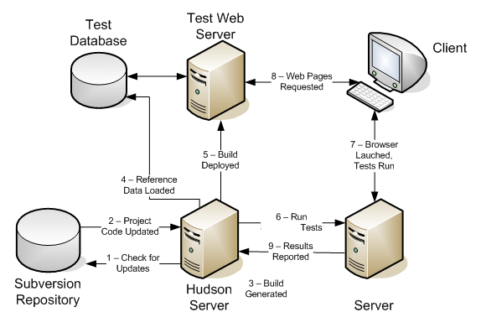 Figure 1: Hudson in real time

Definitions, Acronyms and Abbreviations
Term | Description
Build | Act of integrating the system sub-modules as a single functional unit
CI | Configuration Item
Release | Act of deploying the application and making it available for the user
Change | Any approved modification over the running functionality
CC | Configuration Controller

PM Smart Build Process

Contributing Factors to PM Smart Build Plan
Following are the key factors that have been understand and incorporated for PM Smart build planning:

Area | How it impacts build plan
Nature of Product | The source of input & deployable environment  - A shared development  - Digite, the owner of core CI’s.  - HCLT developed customizations & enhancements.  - A defined build structure, build scripts (Digite & HCLT specific), configuration settings etc. primarily Digite owned.  - Separate Testing, Regression & Production environments.
Development Platform | Platform  - J2EE, Windows  Distributed Development  - Development team at:  - Noida  - Gurgaon  - Bangalore
Frequency & Nature | Frequency of build  - For Testing: 2 to 3 times daily  - For Regression: Once in a month  - For Production: Once in a month  Nature of build (Full/ Patch)  - For Testing: Full  - For Regression: Full  - For Production: Full  - For Hot Fixes to Production: Full  Build Script  - Single Build File (Digite & HCLT specific build files are merged as one).  - Single build file for Testing, Regression & Production builds.
Instances & Deployment | Environment  - For Testing: 2 Instances  - For Regression: As per the need, one of the Testing instance is used.  - For Production, 3 instances  Deployment  - Manual
Execution | Build  - Automated Build using Hudson 1.300  - Less error prone, faster & user friendly
SCM Process & Tool | SCM Process  - Varied CI’s to build  - CI are stored in a different machine  - Subversion is used for SCM  - Can be integrated with Hudson

Build Process
Build failed…What? From the organizations perspective, it’s one of the key process areas that need proper handling else it can easily lead to overrun and increase in software cost. Considering the above factors, PM Smart build process for an end-to-end cycle is depicted below:

Commit the work product to Dynamic
Leads after review will commit the same to Control
Testing Build
Testing Defect Fix
Testing Build & Sign-Off
CC will move the work product to Static
Regression Build
Regression Defect Fix
Perform Development Build
Regression Build
Regression Sign-Off

Tagging the Static Stream

Production Build
Handing over for Deployment

Figure 2: PM Smart Build Process

Dynamic, Control & Static are the streams in Subversion.

Process for CI’s Movement
Dynamic to Control

S. No. | Activity | Owner | Deliverable | Handed Over To
1 | Work Product commit to personal folder in Dynamic stream in SVN | Developer | Requirement doc, Java & DB work products, Unit Test cases, DR report, File List | Lead
2 | Code Merge to control Stream in SVN from Dynamic Stream | Lead | Pre-Release Note | App Support Team
3 | Build & Deployment by App Team | App Team | Notification to stakeholders about the readiness of the testing environment | Testing Team
4 | Testing & Defect logging | Testing Team | Test report & Sign-off | Project Manager

  - For code movement from dynamic to control stream, the cut-off time would be 9:30am, 2:30 pm & 7:30 pm. Any changes after this cut-off time will be considered in the next build.

Control to Static

S. No. | Activity | Owner | Deliverable | Handed Over To
1 | Work Product commit to Static stream from Control Stream in SVN | CC | SVN repository update | APP Support Team
2 | Build & Deployment for Regression | APP Support Team | Regression Environment | Testing Team
3 | Regression defect logging | Test Lead/Manager | Sign-off | Release Manager
4 | Production Build | App Support Team | Deployable Units | Testing Team
5 | Smoke Testing | Testing Team | Sign-off | User Community

Build frequency for Testing: 3 builds daily @ 10 am, 3 pm & 8 pm respectively.
Build frequency for Regression: 2 build daily @ 11 am & 4 pm respectively.
Build frequency for production: one build, 2 days prior to the actual production deployment date.

Code merge, if required, will be done in coordination with the development team

Mandatory

- As long as testing cycle in progress, Control stream in both PMSApp & PMSDb will be read only. This is to ensure that no new CI or existing CI is introduced interim the testing cycle and break the sanity. In case of any Fix (only show stoppers) required within the ongoing testing cycle, the respective CI has to go to control via CC.
- Test Lead/ Test Manager will inform about the planned testing cycles to all the stakeholders & CC well in advance and accordingly Control Stream will be made READ only.
- Once the testing cycle is completed, work products shall be moved from Dynamic to Control.

PM Smart Build Requirements

Software Requirements
Environment/ Tool | Version
Operating system | Windows XP
ANT | apache-ant-1.7.0
WebLogic | 10.0
Hudson | 1.300
Winzip

Configuration Settings for Build
- Weblogic Configuration
  - System level variable
    - PATH: <jdk directory>\bin>
e.g.: D:\bea\jdk150_11\bin

    - PATH: <weblogic>\bin>
e.g.: D:\bea\wlserver_10.0\server\bin;

    - PATH: <Java Home>>
e.g.: %JAVA_HOME%\bin;
- ANT Configuration
  - User level variable
    - ANT_HOME : <Ant directory>
e.g.: D:\apache-ant-1.7.0

  - System level variable
    - Path : <Ant directory>\bin>
e.g.: D:\apache-ant-1.7.0\bin

- Hudson Configuration
  - User level variable
    - Hudson_HOME : <User Defined Path to overwrite predefined Hudson Home Directory>
- Build.xml Configuration
  - Set location of weblogic.jar in property name tag in build.xml (lying in BuildAll folder)
    - <property name="AppServerJar" value = D:/bea/wlserver_10.0/server/lib
    - <property name="JAVAC" value= D:/bea/jdk150_11/bin/javac -J-mx512m
- Application Repository Structure
- The application code for PM Smart consists of following modules:
- Axis
- Birt
- BuildAll
- ExternalJars
- SourceCode
- Webui
- All deployable units go to BuildAll\dist10 folder

Build.xml Details
Build.xml is the “Master of All”. If this file is not configured properly or made available to ANT, out will be a bunch of errors. As we know, we have separate build files w.r.t Digite & HCL CI’s. Although many of the targets have similar objectives but still we are compiling them individually, like Ejbs.jar, HCLEjbs.jar & Portalejbs.jar. In addition, many of the Digite provided targets are not required in HCLT environment and unnecessary adding to build cost.

Let us have a quick glance into the targets which are in existence today as per the unified build file (build.xml), which is actually just a merger of Digite & HCLT build files.

Target | Interim units produced | Final deployable unit
CmpCommon |  | common.jar
CmpEjbs | Standard.jar | ejbs.jar
CreateapjdbcJar |  | apjdbc.jar
CmpWebServices |  | digiteWS.jar
CreateWAR | Webclient.jar,webpages | digite.war
CmpPortalEjbs |  | portalejbs.jar
CreatePortalWAR | webpages | Portal.war
CreateLDAPJar | ldap-plugin
CreateLDAPPlugin | ldap-plugin
CreateAxisWAR |  | axis.war
CreateBirtWAR |  | birt.war
CmpHCLJar |  | digitehcl.jar
CmpHCLEjbs |  | HCLEjbs.jar
CreateHCLWAR | webpages | digitehcl.war
CmpHCLCommonJar |  | HCLcommon.jar
CmpFonterraWebservices |  | fonterraWS.jar

After the detailed analysis the build file has been modified, redundant targets have been merged as a single compliable unit, targets not required in HCLT environments have been removed and certain changes have been made in the descriptors to achieve the new sanitized build.xml. Here it goes…

Target Name | Mapped To | Interim Units Produced | Final Deployable Unit
CmpCommon | - CmpHCLJar  - CmpHCLCommonJar  - CmpCommon |  | common.jar
CmpEjbs | - CmpPortalEjbs  - CmpHCLEjbs  - CmpEjbs | Standard.jar | ejbs.jar
CmpWebServices |  |  | digiteWS.jar
CreateAxisWAR |  |  | axis.war
CreateBirtWAR |  |  | birt.war
CmpFonterraWebservices
ConditionalWorkFlowJar
Kedb
CmpEjbClient

Against 16 targets earlier, we have to build only 6 targets now plus few new HCLT developed related targets. Following targets have been removed:
CreateHCLWAR, CreateLDAPPlugin, CreateLDAPJar, CreatePortalWAR, CreateWAR, CreateapjdbcJar

A long pending issue in our build file was duplication of classes among different jars. In the new build file, following has been addressed up to the applicable extent. Let’s undergo the changes made to achieve the same.

- Previously, a single class was becoming part of multiple jars during compilation which was creating ambiguity at runtime and also a dilemma for the developers. To remove this redundant appearance of classes, three jars common.jar, HCLcommon.jar & digitehcl.jar are merged to one as common.jar.

- Same was the case with EJB jars. CmpPortalEjbs, CmpHCLEjbs & CmpEjbs have been merged as a single ejbs.jar. To facilitate the same, respective descriptors (ejb-jar.xml, weblogic-cmp-rdbms-jar.xml & weblogic-ejb-jar.xml) present under HCLdescriptors, Portaldescriptor, Descriptors are merged together and are available under buildall\unifieddescriptors.

- In order to stop EJB stubs moving to common.jar as well as ejbs.jar, a new jar is created as ejbClient.jar that will contain only stubs classes.

- Axis & Birt were deployed in the exploded form earlier. The modified build file will create axis.war & birt.war and the same will be deployed as such through weblogic.

Hudson Setup

Hudson Installation
- First, you need to start Hudson before installing it. This can be done from JNLP, or by running java -jar hudson.war". Make sure JAVA is installed in your build machine.

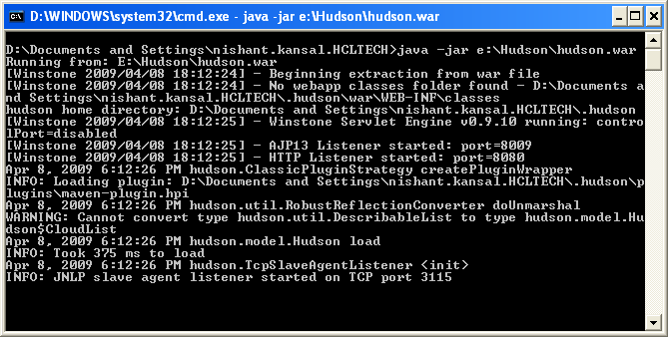
Figure 3: Hudson Booting Up

- Open browser and type http://localhost:8080/ and you will be in to Hudson

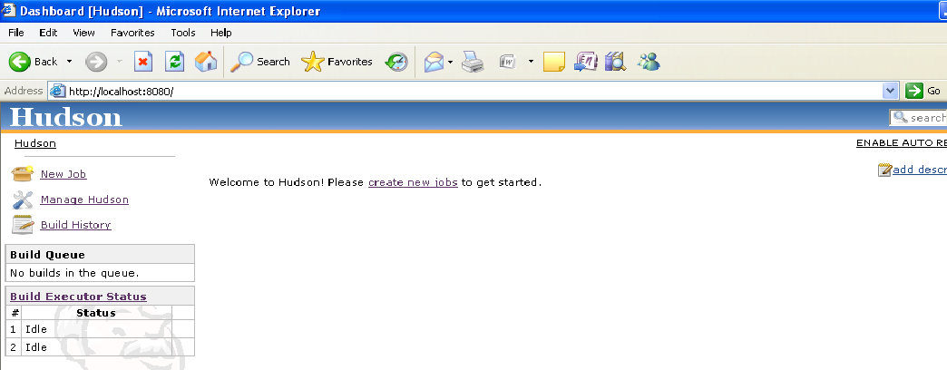
Figure 4: Hudson's Front Page

And Hudson is ready to serve you.

For more details on installation, please refer to Hudson

How to use Hudson?
At the front page on the left, you will find three features, namely
New Job
Manage Hudson
Build History
First, we will discuss “Manage Hudson” option and then how to setup a “New Job”.

Manage Hudson
On clicking, “Manage Hudson” you will take us to (please refer to Figure 4) “global settings” through “Configure System” option, adding plugins for SCM repository and more through “Manage Plugins” option. Similarly, there are other options for system information, stats, logs etc.

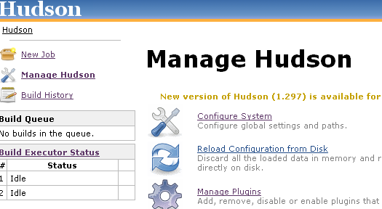
Figure 5: Manage Hudson Screen

“Configure System” is of our primary concern. Out of the various fields under this option, “JDKs”, “Ant” and “E-mail Notification” are of main interest. Provide values to these fields as per the setup in your build machine. Keep a note of Hudson’s “Home Directory” at the top. Click “Save” at the bottom to retain your provided settings. We can proceed now for setting up a “New Job”.

New Job
Clicking on, “New Job” option will take us to the options for selecting the nature of job that we want Hudson to perform.
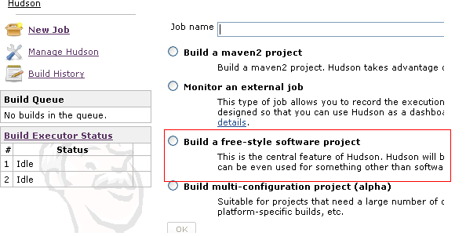
Figure 6: New Job Screen

- Give a proper name to your job (for e.g. Test Build) and select “Build a free-style software project”. Click “ok” will take us to the next stage (please refer to Figure 6), where we have to configure the properties for the job created above.
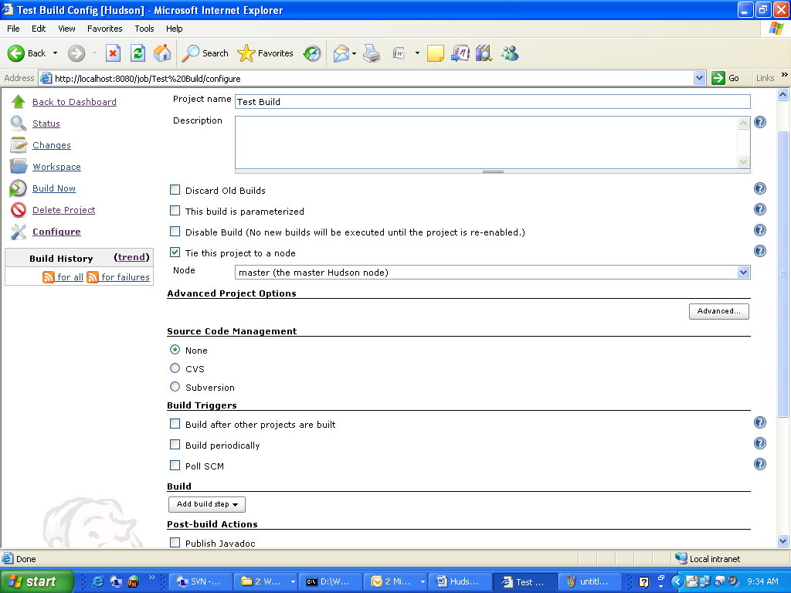
Figure 7: Configure Properties for job created in previous stage

- Once you are done with the configuration, click “save”, you are ready to run your first build using Hudson.
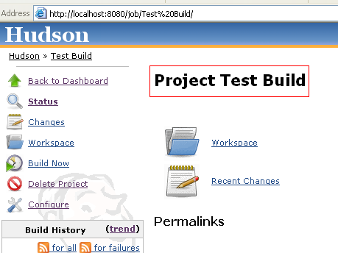
Figure 8: Job Execution Screen

- Go back to the front page of Hudson, you can find your created job

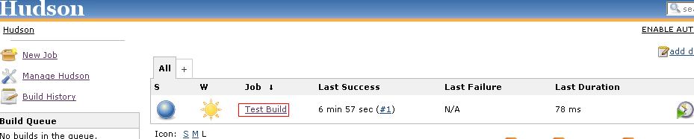
Figure 9: Job Screen

